Wee Care Program October 8, 2020
Tricks & Tips
Joyce Ross and Sandy Suhrie Wee Care Co-chairwomen

- Gown seams- Serge side seams using a 3-thread narrow hem setting. Practice on similar fabric as your gown fabric and adjust your serger until you like the stitch. You could leave it with a serge edge or finish into a French seam. Both would be acceptable.

- Tip: Sew seams starting at the bottom and finish at sleeve edge but make sure the start and finish ends all meet. You may have to ease some as you stitch. If the edges are way off trim bottom edge before sewing.

- Sleeve Tip: If you have lace or trim on a sleeve and want to start sewing at the sleeve edge, use a piece of tear-a-way stabilizer to prevent the machine from forming a knotted mess or the feed dog from pulling it into the bobbin case.

- Top pleating thread: I prefer to remove the top pleating thread at the neck edge. I insert my ribbon, pull up and tie the ribbon before I fan out the
Gown and make it ready to tie off and block. *B. Meger

- How many Strands of floss: The answer depends on the type of floss you are using and what effect you want your finished smocking to take on. With a light and delicate fabric, you want to use two stands of thread in most cases. i.e.: DMC, Madeira silk, or Anchor embroidery threads. This is not the case if you are picture smocking. Tip: An exception is my example of the micro-check blue gown. I used 3 strands of Cascade Silk threads in a light yellow so it would contrast from the fabric.

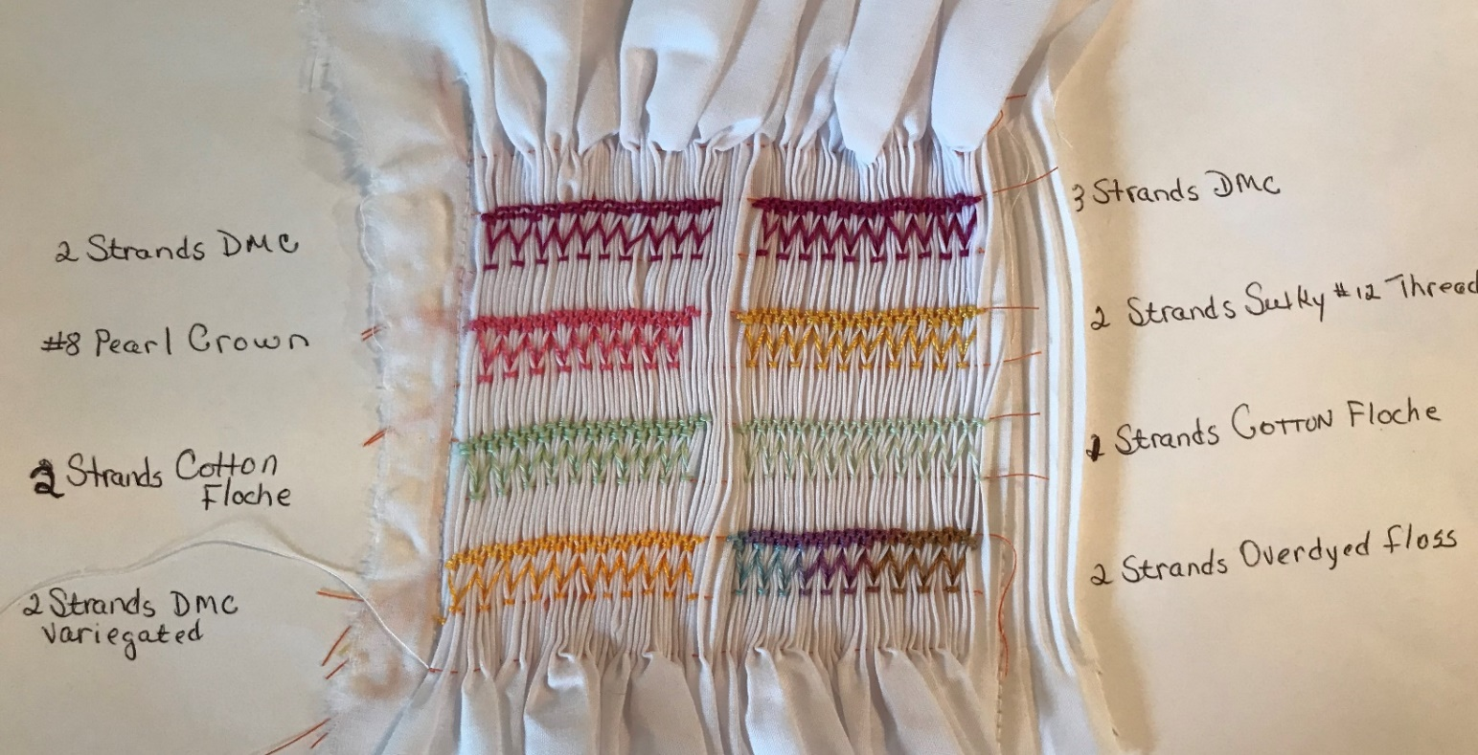

- Buttons on gowns and caps: If you want to use different buttons than what are supplied, feel free to do that. I substituted larger buttons from my collection on the large size boy caps. They seemed proportioned with the size of the cap. Let’s be creative! Tip: before turning boy bonnet press seam opening to give a pre-set closeure.

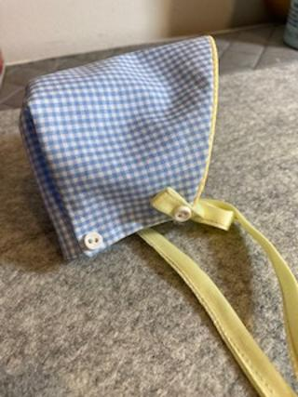: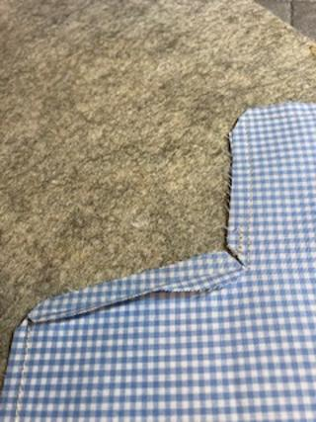 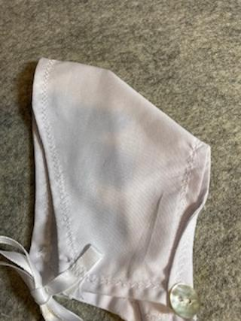

- Bonnets: A feminine touch to the bonnets is always a fun idea. Take a piece of small leftover edged lace and make a rosette and fasten your ribbon ties
to the rosette and attach to bonnet. * J. Messinger 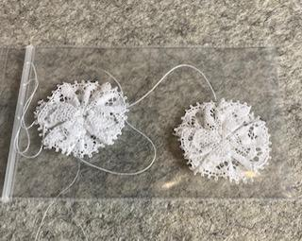

- Hem embroidery: Adding hand or machine embroidery to the hem is a great finish to your gowns. It draws your eye to the hem and says you went the extra step. Try a design of your own or look through magazines, patterns, and Internet for design ideas.
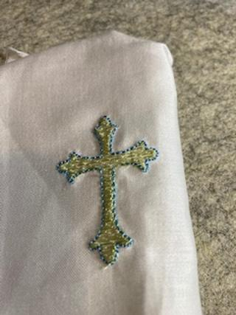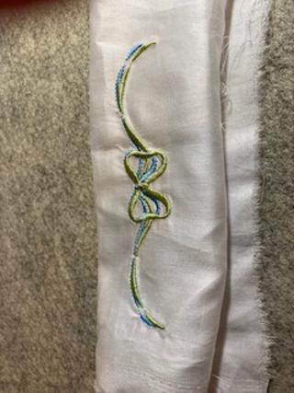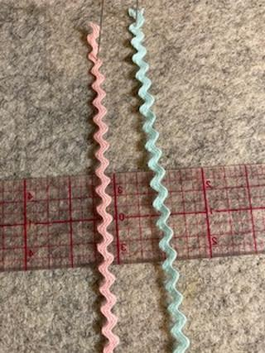

These are some samples of hemming done with sewing machine stitches. If your stitching is puckering – use some embroidery stabilizer under the fabric. You can stitch a scallop stitch with the hem turned up. Then carefully trim behind the hem. I used polymesh stabilizer in the hem.
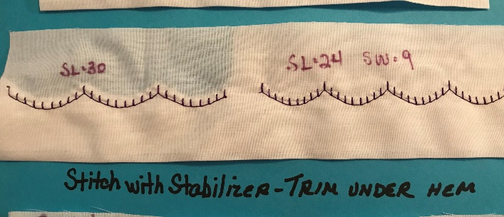

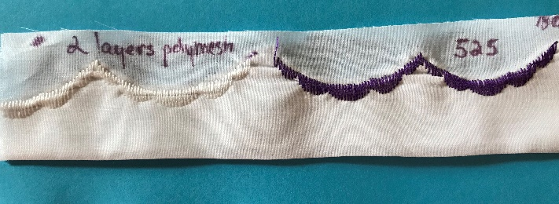

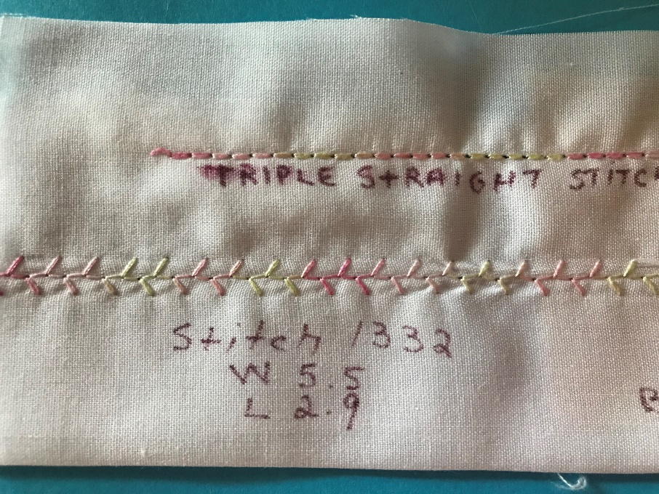

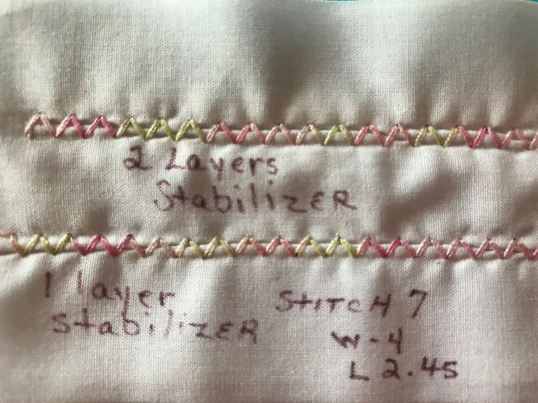
The sample above is with 30wt cotton thread. It is a feather stitch and a triple straight stitch. Stabilizer is needed. The sample below is just machine stitches using stabilizer in the hem. The one on the right is a triple zigzag and needs two layers of stabilizer, not one.
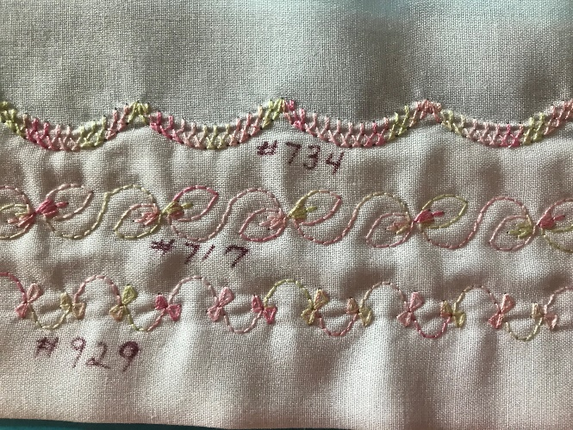

This is a sample showing how to weave floss through a straight stitch hem. I used a 3.0 length to hem. I also used my serger to make a 3-thread rolled hem trim. I used that to weave through this sample using a blunt end needle. I also tried a loose blanket stitch, but this trim was a bit thick.
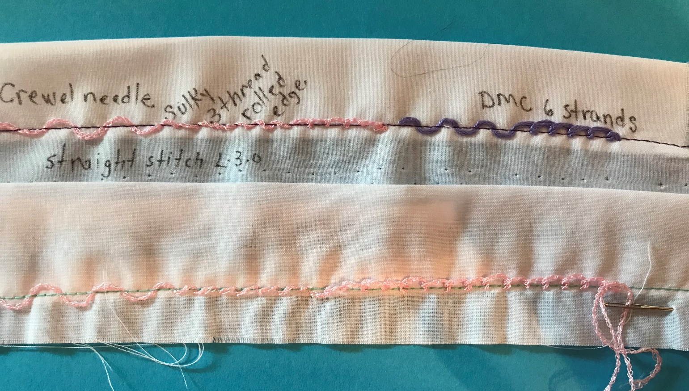

This sample was done with a strip of fabric (may be cut on the bias if there are curves.) I cut a 1” piece of fabric, pressed a ¼” under on each end and then topstitched it to the hem after stitching it to the bottom of the dress.
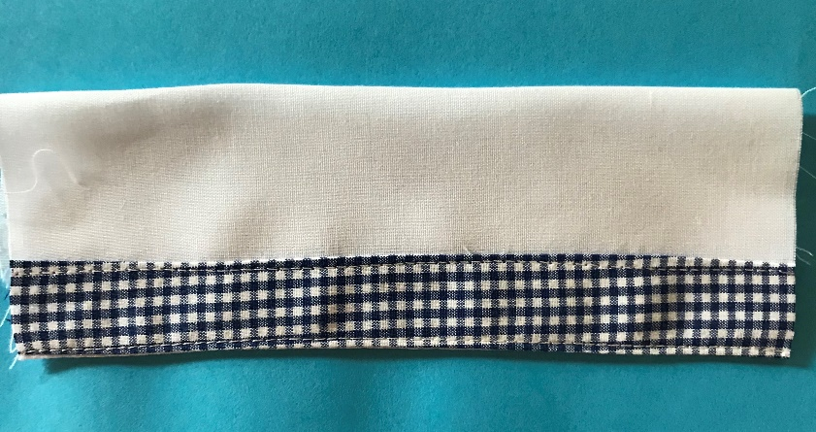

- Tip: I love the smocking part of Wee Care gowns more than the construction. Did I just say that out loud? Just being honest! Construct your gown prior to smocking. Finish your side seams and hem. Then the hand work can begin. I save the best for last!

- Smocking plate: We offer many designs for gowns in your C.T. Handbook. Sometimes we just want to breakout and try something more challenging or up our skill level. Think about designing your own smocking plate. You may want to incorporate more difficult stitches to make it even more challenging.

*Special thanks to Joan Messinger for her sample of the ribbon rosette.
*Please see Blocking instructions previously posted by Barbara Meger. Thanks, ladies for your knowledge and instruction.

