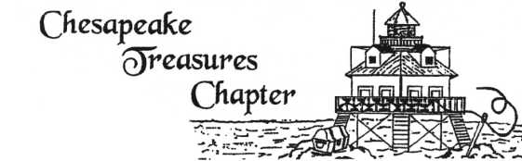

Newsletter November 2023

November Program Information
I wanted to give you some time to review the directions and gather your supplies for the Nov. Mini Hoop embroidery program.

You will need to supply your own design – about 1” in diameter - and trace it out on light weight water soluble stabilizer before the meeting. I used sticky water-soluble stabilizer, and it worked much better than trying to free hand or draw onto Organdy. If you would like to try this, I will have some at the workshop. Have your design traced out on paper and it should be transferred to the stabilizer with no problem.

I will bring my Spinster Cord maker for anyone who would like a Corded hanger.
Please bring the perle cotton or embroidery floss you would like to use for your twisted cording. Bring 2+ yards of each color.

I originally saw Mini Hoops as a necklace. Christmas will be here shortly, and I decided to make it an ornament. Please enjoy the time creating your design and have fun! I will send some pictures via my phone in a separate email for more inspiration.
Joyce R.
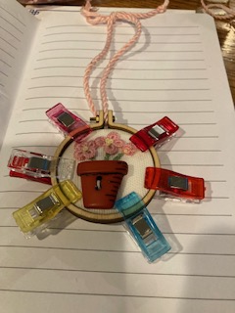

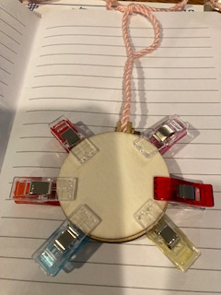
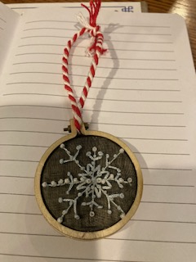

Your Co-Builder Opportunity For 2023-2024
We sincerely hope that you will join Our Chapter in supporting the Co-Builder Opportunity this year.
Please come and join us this 2023-2024 Chapter year with a subscription for 8 drawings (October through May). The drawings will take place just as they did last year.
December 1, 2023, is the final date for accepting the Co-Builder Opportunity 2023-2024 Subscriptions.
We hope all our members will support the chapter, in this way, this coming year.
For those of you who participated last year, thank you again for helping make last year a successful year for the Chapter.
Chesapeake Treasures Co-Builder November 2023
Another great surprise of the year! Looking to make last minute Christmas gifts? Well, here are a variety of fabrics and trims that can help you along the way!
- 5 yards of decorative ribbon. Red background with Christmas trees
trees and bears – I” wide.
- 5 Yards of decorative ribbon. White background with Christmas
trees and bears 1” wide,
- 4- one-yard pieces of Fabric –all with Christmas bears. Different
backgrounds and designs.
- 1- two-yard piece of Fabric- bear and holly Christmas design.
- 1- three-yard piece of Fabric – Christmas toy soldier design.
- “Elegant Embroidery” a delightful book by Kaye Pyle from
Australia.
- A case of small tools for sewing and embroidery
- Donated by Marlene Mehn – from Wendy’s Embroidery Club.
Wendy Schoen Design “Italian Hemstitched Play suit or Dress”,
Drawn thread bars as well as basic hemstitching instructions.
Chesapeake Treasures Co-Builder December 2023
For those really last-minute projects or put away until the time that you have nothing to do over the holidays?????

- 6 yards of holiday fabric with a red background.
- 2 yards of green Christmas trees on white background fabric.
- 2 yards of snowmen on red background fabric.
- 2 yards of swan design on red background fabric.
- 5 yards printed ribbon -Santa.
- 6 yards printed ribbon -Holly Leaf.
- 5 yards printed ribbon -Rocking Horse ---white background.
- 5 yards printed ribbon -Rocking Horse ---red background
- Holiday Bouquet Medley from Keepsake Quilting- fat quarters.
- A surprise packet of small sewing tools.
- Donated by Marlene Mehn - Wendy Schoen Designs – “Smocked
Baby Coat”. Many sizes, many fabric possibilities.
Happy Holidays to all. And to all Happy Stitching.
Mary Margaret Kasulke and Joan Messinger, Co-Chairs

WOW, What A Convention! By Joan Messinger
The 2023 SAGA Convention in Charleston, S.C. was super. So well planned. Rooms were spacious and comfortable, and the elevators were quick to access. When we checked in, we received our packet that contained lots of information. Among those things was a 2 X 3½ double fold card. It was fantastic for it contained in a nutshell, every important bit of information—time, place, events, a sketch of class location and teacher location—everything you could possibly need. It fits perfectly in your name tag pouch, too.
Meals were very good, with a great variety on all the buffets. The banquet was well planned, and since we had pre-chosen our entree, it was correctly served.
Classes were all on the same level in the Conference Center and were very roomy. Hand classes were 2 to a table. You could really spread out your supplies. Although I did not take any machine classes, I could see there was ample room for machines and supplies there too. I took a class from Vaune Pierce and learned a new twist to improve my granitos. (I had had a project before in which I did over 100 granitos but I learned something new this time —Aren’t choices great!!). Phyllis Browns class, a notebook class was super- so many practice pieces and great hints to refer to in “pulled and drawn thread techniques.
I decided on a ½day class from Tess Ellenwood. It was an ornament that was shadow work done from the reverse side, Yes, you can get the same results as from the traditional way, but it takes practice! Then Judith Addams taught a sampler that was a follow up (more advanced) from a sampler I had done with her almost 20 years ago. We worked with tiny seed beads (under magnification) and used a variety of silk and cotton threads on pleated linen. It is a work in progress now. On the final morning I has Ann Peebles, a new teacher to the SAGA group and she introduced Caramacross, an Irish embroidery technique that I had never done before. It was an eye opener to what you can do on fine netting.
Can’t leave this summary without the “Banquet” The drawings and favors were delightful. Several of our Chapter members won baskets and we learned that next year the location for the 2024 Convention will be in Hampton Roads, VA--- OUR BACK YARD! It is within easy driving distance. Hopefully all of you will be able to attend. You can come part-time if your work or budget cannot let you come for 5 days. Plan---now----. It can be a little easier that way. Just an added hint- Years ago my whole family gave me a collective Christmas gift and Birthday gift combined of money for classes, travel, hotel expenses and kit fees. As I said, just a hint to let them know what would be a great “adventure” for you.

Stitching Discoveries from Around the World!
by Barbara Meger
Returning to our hotel one evening during a stopover in Amsterdam a couple of months ago, we walked by this charming shop whose window was filled with lovely, smocked dresses and other handmade items. I posted a picture to a Facebook group and one of the other members, who happens to live in the Netherlands, commented that SHE had made the smocked dresses in the window! It turns out that the shop is an outlet for Tesselschade-Arbeid Adele (TAA), the first national women’s association in the Netherlands. It was incorporated in 1871 to support women in their aim for economic independence. The organization also endeavors to conserve the knowledge and preservation of handicraft techniques. (Sounds a bit like SAGA!)
I returned when the shop was open and had a delightful exchange with its volunteer staff. They mentioned that some of the smocked dresses were made in Vietnam. (I had actually seen some in a market in Saigon last winter.) In addition to smocked items—enjoy the accompanying photos—there were crocheted animals and cross-stitch embroidered accessories.
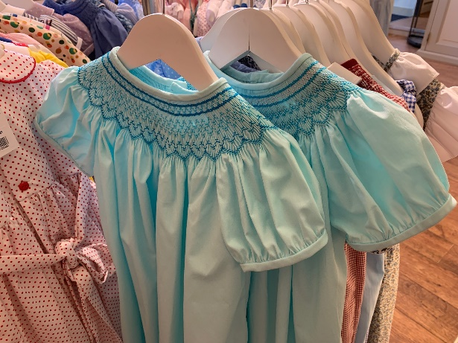
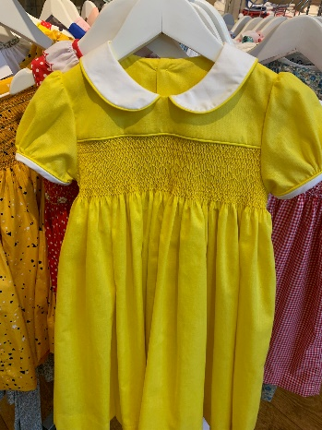
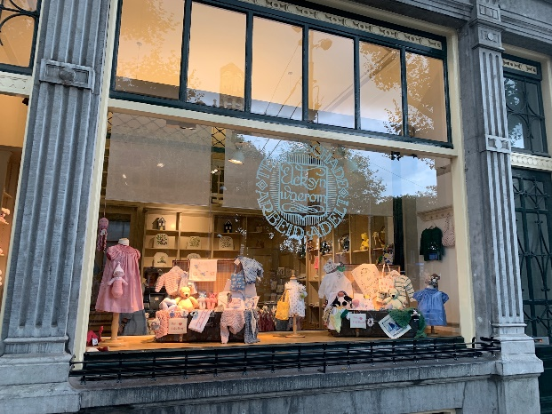
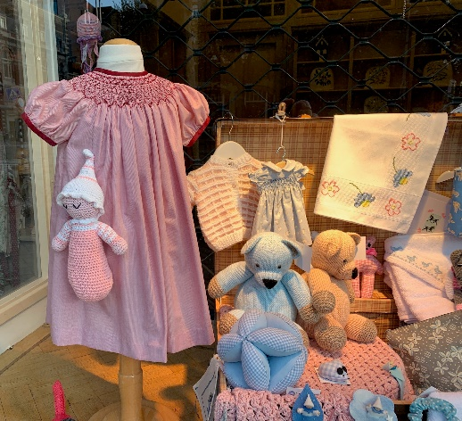
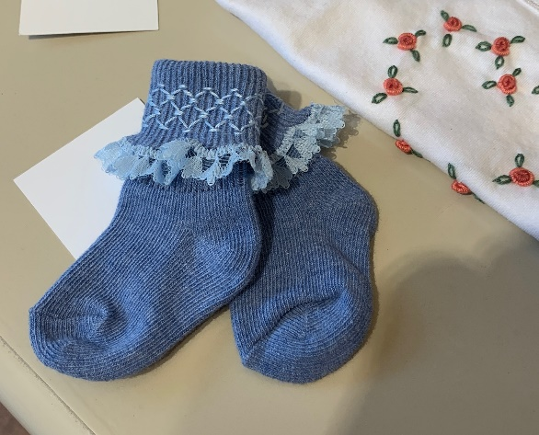
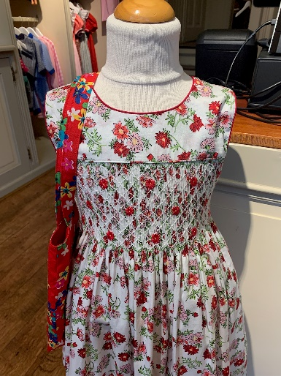
MEETING DATES 2023/2024
November 9, 2023 December 14, 2023
January 11,2024 February 8, 2024
March 14, 2024 April 11, 2024
May 9, 2024 June 13, 2024

Officers of Chesapeake Treasures 2023/2024
Lynn Leet, President Shannon Fraley V.P. Programs
leetmv@comcast.net shannonfraley@gmail.com
443 994-4576 719-244-3175

Lindsay Carroll, V. P. Membership Terri Janvier, Secretary
lindsaystitching@gmail.com thejanviers@gmail.com
410-842-3773 443-995-0481

Morganlee Pazdur, Treasurer
Morganl Lee.pazdur@gmail.com
518-542-3432

We are on Instagram under Chesapeake Treasures SmockingChapter – Brooke Palmer
Contact Carolyn Dalton if you want to add something to the website www.chesapeaketreasures.org . Carolyn has lots of information on our website. Be sure to check it out!

November | 3- Terry Janvier  7 – Sally Rifenburg  27 – Lyn Leet
December

When and where we meet: Watch your email for any changes.

The Chesapeake Treasures Chapter meets at 6:00 pm the 2nd Thursday of the month at

Crofton Library, 1681 Riedel Rd, Crofton, MD

At each meeting there is a show and share, a program or demonstration.

Business meetings are held at the beginning of our regular membership meeting.

Should there be inclement weather, please check the library site to see if they are open or call 410-222-7915 https://www.aacpl.net/location/crofton

SAGA—The Smocking Arts Guild of America - “Our purpose is to preserve and foster the art of smocking and related needlework for future generations, through education, communication, and quality workmanship.”
www.smocking.org

